More about Cyrene’s Family:

William H. Hawkins, III
Birth: | May 10, 1771  Halifax County  Virginia, USA
Death: | Apr. 2, 1843  St. Louis County  Missouri, USA
The son of William and Elizabeth Hawkins, Jr., William (III) moved with his parents to North Carolina when he was 12-years-old.
William married Nancy Walton on 20 Mar 1802 in Rutherford County, North Carolina. She was the daughter of William Walton and Mary Hanson Hunt.
William and Nancy Hawkins were the parents of 12 children, and he supported the family as a farmer. They moved first from North Carolina to Christian County, Kentucky. From there, they moved near the town of Labaddie in St. Louis County, Missouri in 1811.
After Nancy's father, William Walton died in 1826, she received a sizeable inheritance. The Hawkins attended Fee Fee Baptist Church in northwest St. Louis County, and William was a trustee of the Mount Pleasant School. It was founded in 1836 and several of their children attended school there.
At the time of William's death in 1843, he was 71 years 10 months and 23 days old. He was survived by his wife, Nancy.
Gold was discovered in California 5 years after William died. 3 of his sons--William, Washington Jackson and Jacob--left their families about 1849 and headed for California.
Nancy Walton Hawkins passed away in 1852.
Children: 4 daughters, 7 sons.
Father of:
Malinda C. Hawkins Link
Lucinda Hawkins McDonald
Elizabeth Hawkins Musick
Mary "Polly" J. Hawkins Martin
William H. Hawkins IV
John Hawkins
Henry Hawkins
James William Hawkins
George W. Hawkins
Washington Jackson Hawkins
Infant Boy Hawkins
Jacob W. Hawkins
Family links:
Spouse:
Nancy Walton Hawkins (1781 - 1851)
Children:
Malinda C. Hawkins Link (1804 - 1887)*
Mary J. Hawkins Martin (1806 - 1870)*
*Calculated relationship
Inscription:
William's stone:
WILLIAM HAWKINS
Born in Halifax Co., Va.
May 10, 1771
Emmigrated to Mo. 1811
Departed this life
April 2, 1843
Nancy Hawkins' stone:
NANCY HAWKINS
Consort of
WILLIAM HAWKINS
Born in Rutherford Co., N.C.
July 6, 1781
Died August 2, 1852
Note: Unable to find any readable grave marker for William or his wife, Nancy. Inscriptions taken from an old Fee Fee Cemetery book.
Burial:
Fee Fee Cemetery
Bridgeton
St. Louis County
Missouri, USA

Nancy Hawkins Walton Underwood
Birth: | Oct. 28, 1814  Missouri, USA
Death: | Sep. 5, 1870  Missouri, USA
Nancy Hawkins (Walton) Underwood, d/o James B. & Isabella (Musick) Underwood, was married to Jesse B. Underwood with whom she had 7 children, Dawney, James, Fred, Cyrene, Charles, Joseph and Virginia Underwood.
UNDERWOOD - Nancy departed this life in St Louis co, 5 Sept 1870 aged 55 yrs 11 mos 7 das. She was the daughter of James & Isabella Walton and consort of Jesse Underwood. She was converted during a series of meetings held at Ritnor's School House, about 12 years ago, and was one of the organization composing the first class of what is now Mt. Olive Church. May God bless the bereaved husband and children. - W D Shumate.
[Abstracts of obituaries published weekly in the St. Louis Christan Advocate. Obituaries January 1870-June 1872.]
(Contributed by Sherida (Riggs) Childers)
Family links:
Parents:
James B. Walton (1787 - 1851)
Isabella Musick Walton (1792 - 1864)
Spouse:
Jesse B. Underwood (1806 - 1876)*
Siblings:
William M. Walton (1809 - 1880)*
Mary Walton Jones (1811 - 1882)*
Nancy Hawkins Walton Underwood (1814 - 1870)
Cyrene Clemens Walton Hanley (1819 - 1894)*
Frederick B. Walton (1826 - 1919)*

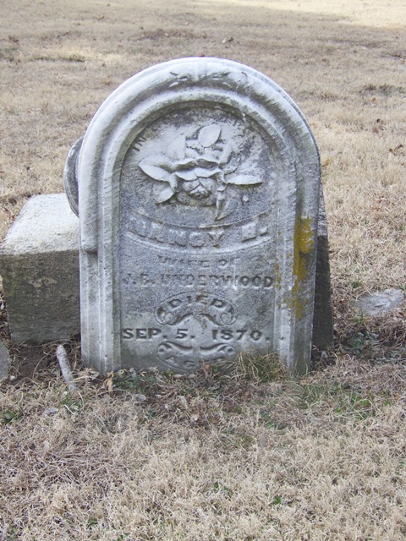

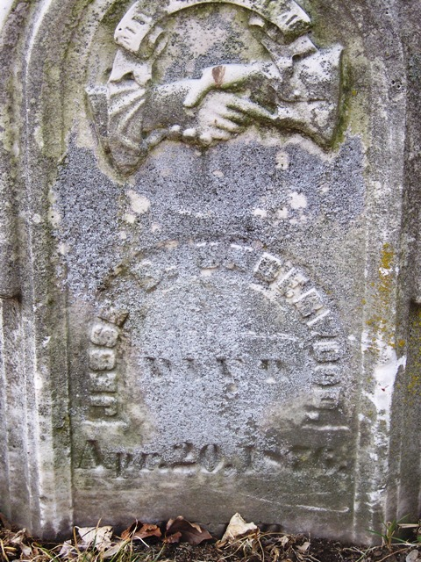

George Walton
Birth: | 1779  Virginia, USA
Death: | Mar. 24, 1843  Cole County  Missouri, USA
George was 1 of 11 children born to William Walton and Mary Hanson Hunt. In 1792, the Walton family moved from Virginia to an area just west of the Mississippi River and south of the Missouri River. The land would eventually become part of northwest St. Louis County, Missouri, but it was under Spanish control at the time the Waltons moved there.
Like many of their neighbors who also came from Virginia, George's parents brought their slaves with them. Reports say that they owned a total of 110 men, women and children.
George's father acquired a large amount of land for agricultural development. He established a large plantation in and around what is now known as Overland and Bridgeton, Missouri.
George married Elizabeth McDonald (or Clary) about 1805. [Some sources give a marriage date for George Walton and Mary "Elizabeth" Clary as 15 Jan 1803 in Warren County, Kentucky.]
George and his wife were the parents of at least 7 children. He was a farmer.
George's wife, Elizabeth, died in 1837 and was buried at Fee Fee Cemetery in St. Louis County. Her tombstone is still standing and most of it is still in readable condition.
George died on 24 Mar 1843 in Cole County, Missouri. Some records have him listed as being buried at Fee Fee Cemetery in the same lot as his wife. There currently is no marker for his grave.
George and Elizabeth's oldest daughter, Nancy Martien, died in 1846. Cemetery records indicate that she was also buried in the Walton Family lot. Her tombstone is in very good condition.
To this day, the Walton name is still remembered in St. Louis County. On the eastern edge of Overland, a street called Walton Road runs from Page Avenue to St. Charles Rock Road. It was named in honor of George's family.
Children: 6 daughters, 1 son.
Father of:
Nancy M. Walton Martien
William L. Walton
Louisiana Walton Hoops
Elizabeth Walton
Amanda Walton Hoops Cox
Harriet E. Walton
Rebecca J. Walton Biles
George's siblings:
Meshack Walton
John Taylor Walton
William Walton, Jr.
Jacob Walton
Nancy Walton Hawkins
Elizabeth Walton Lunsford
Henry J. Walton
James B. Walton
Rebecca Walton Chapman
Joseph Walton
Family links:
Parents:
William Walton (1742 - 1826)
Mary Hanson Hunt Walton (1761 - 1838)
Spouse:
Elizabeth McDonald Walton (1789 - 1837)*
Children:
Nancy M. Walton Martien (1807 - 1846)*
William L. Walton (1809 - 1876)*
Amanda M Walton Cox (1820 - 1913)*
Rebecca Jane Walton Biles (1828 - 1908)*
Siblings:
George Walton (1779 - 1843)
Nancy Walton Hawkins (1781 - 1851)*
Jacob Walton (1784 - 1848)*
James B. Walton (1787 - 1851)*
*Calculated relationship
Note: There is no marker for this grave.
Burial:
Fee Fee Cemetery
Bridgeton
St. Louis County
Missouri, USA
Plot: Block 1, Lot 69
Jacob Walton
Birth: | 1784
Death: | 1848
h/o 1st, Jane Goode, 2nd Sophia Jenkins.
Walton ancestors from England, reportedly descended from Sir Izaac Walton (1593-1683).
Birth: 5th of eleven known children in Virginia.
Reportedly removed with family and their 110 slaves, in 1792 to Spanish territory west of what is now Mississippi river near its confluence with Missouri river at age eight, while still under control of Spain, purchased eleven years later in 1803 by United States, now Saint Louis county. His father amassed a large plantation near present day Bridgeport and Overland, Saint Louis county, Missouri with father, Wm in 1826, mother, Mary in 1838 and at least nine other family members buried in ParkFee Fee cemetery.
Jacob and two brothers were executors of father's will.
Jacob apparently removed to Tipton county, Tennessee, downstream from Saint Louis, where with first known wife, Jane Goode (1785-1830) son Thomas Goode was born 16 NOV 1805, likely back to Saint Louis county before heading for southwest Missouri's Wayne county till January 1833, Greene county till January 1835 then Barry county. Move was prior to 1834 when Jacob and early Jasper county pioneer from Kentucky, Thackery Vivion, who was first noted at Centerville, now Sarcoxie, in 1831, around time Crawford was split from Wayne county, then split to Greene in 1833, with Barry split from Greene in 1835, both men recorded as having livestock, Jacob with three horses and five heads of cattle and where he was married, for at least second time, in 1837 to Sophia Jenkins. By this point in time, Barry county had been split from Greene county later, January 1841 Jasper county, as well as five other counties being created at different times from Barry county, with Barton from Jasper in 1855.
Death: in Jasper or Barry county, Missouri.
Father: William Walton b: 1742 Virginia.
Mother: Mary Hunt b: 1761 Bedford county, Virginia.
Marriage 1 Jane Goode b: about 1785.
Married: about 1805, location currently unknown.
Known Children
Thomas Goode Walton b: 16 NOV 1805 Tipton county, Tennes
Matilda Walton b: 1807
Joseph Walton b: 1809
George S. Walton b: about 1821
Marriage 2 Sophia Jenkins
Married: 1837 in Barry county, Missouri.
Children unknown.
Family links:
Parents:
William Walton (1742 - 1826)
Mary Hanson Hunt Walton (1761 - 1838)
Children:
Thomas Goode Walton (1805 - 1864)*
George Ferguson (1809 - 1884)*
Siblings:
George Walton (1779 - 1843)*
Nancy Walton Hawkins (1781 - 1851)*
Jacob Walton (1784 - 1848)
James B. Walton (1787 - 1851)*
*Calculated relationship
Burial:
Unknown

James B. Walton
Birth: | Dec. 27, 1787  Augusta County  Virginia, USA
Death: | Aug. 16, 1851  Bridgeton  St. Louis County  Missouri, USA
James B. Walton, the son of William & Mary (Hunt) Walton, was married to Isabella (Musick) Walton with whom he had 9 children, William, Mary, Meshack, Nancy, James, Cyrene, Frederick, Eliza and Thomas Walton.
Family links:
Parents:
William Walton (1742 - 1826)
Mary Hanson Hunt Walton (1761 - 1838)
Spouse:
Isabella Musick Walton (1792 - 1864)
Children:
William M. Walton (1809 - 1880)*
Mary Walton Jones (1811 - 1882)*
Nancy Hawkins Walton Underwood (1814 - 1870)*
Cyrene Clemens Walton Hanley (1819 - 1894)*
Frederick B. Walton (1826 - 1919)*
Siblings:
George Walton (1779 - 1843)*
Nancy Walton Hawkins (1781 - 1851)*
Jacob Walton (1784 - 1848)*
James B. Walton (1787 - 1851)
*Calculated relationship
Burial:
Fee Fee Cemetery
Bridgeton
St. Louis County
Missouri, USA

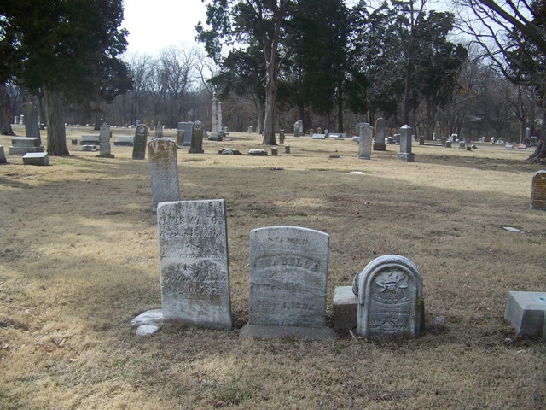
From left to right: James B. Walton; Isabella (Musick) Walton; Nancy (Walton) Underwood. Nancy's husband, Jesse, just off the picture to the right.

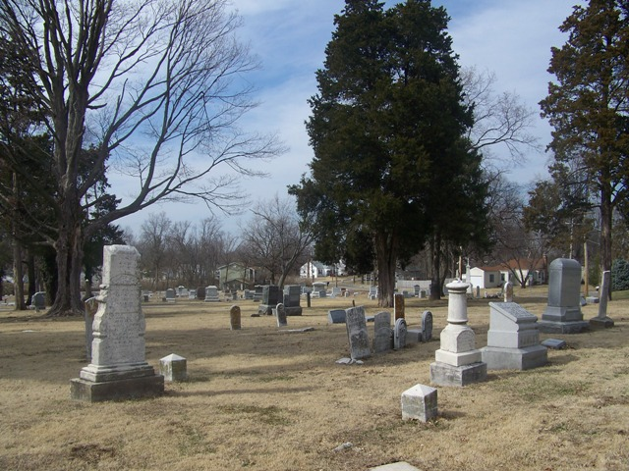
James & Isabella (Musick) Walton and Jesse & Nancy (Walton) Underwood located at center of picture

Henry C. Hanley
Birth: | Aug. 18, 1818  Virginia, USA
Death: | Jan. 10, 1884  Clayton  St. Louis County  Missouri, USA
The son of Robert Hanley and Mary Guthrie, Henry C. Hanley was born in Virginia. He was the younger brother of Martin Franklin Hanley. Both of the boys eventually headed west and settled north of the city of St. Louis, Missouri.
By 1850, Henry lived in what would one day be known as St. Louis County with the large family of his brother, Martin, and his wife, Cyrene Clemons (nee Walton) Hanley. At that time, Henry and his brother worked as a blacksmiths.
The blacksmith shop was of fairly significant size and importance. In addition to the Hanley brothers, 2 other blacksmiths lived on Martin's land, as well as a blacksmith laborer.
Later in life, Henry took up farming. Hanley Road, named in honor of Henry's family, is located in what is now the northwest part of St. Louis County. Walton Road, named after the family of his sister-in-law, is also located in the same area.
Henry was not married at the time of his death. (Note: Missouri records include the marriage of a Henry C. Hanley to Theresa Holveher on 26 Dec 1869 in St. Louis. Unable to confirm whether or not this was the same Henry C. Hanley as the subject of this memorial.)
He died of pneumonia at the age of 65 years, 4 months and 23 days. According to St. Louis death records, he died on Hanley Road near Clayton. The attending physician was Dr. John J. O'Brien.
He was survived by his sister-in-law, Cyrene Hanley; and several nieces and nephews, including Nancy Caroline "Cal" Hanley.
Henry was preceded in death by his brother, Martin, who passed away in 1879.
There are 2 stones for Henry's brother, Martin, at Fee Fee Cemetery. He shares a newer marker with his wife, Cyrene.
Next to the stone for Martin and his wife is an older headstone, also engraved with Martin's name and dates. His side is still readable, but the reverse side is extremely weathered. Only the dates on that side are still legible. (See first and second photos at right.) As a consequence, that side of the monument remained unidentified for several years.
Very special thanks go out to Find A Grave contributor Jennie for identifying the reverse side of the stone as belonging to Martin Franklin Hanley's brother, Henry C. Hanley.
Jennie had a great-aunt who was fond of saving poems that were printed in Missouri newspapers. The collection was passed down in the family and saved by a niece, Jonnie Sue (nee Gattis) Kelley. In 2015, Jennie discovered that Henry's death announcement happened to have been published on the back side of one of her great-aunt's clippings.
----------
Death notice:
HANLEY--January 10, at the residence of his late brother, M. F. Hanley, HENRY C. HANLEY, aged 65 years, of pneumonia.
(Most likely from a Grape Grove or Richmond, Missouri newspaper; early 1884)
Note: All spelling, capitalization and punctuation marks in death notice are exactly as they appeared in the original text.
Note: Double click on photos to enlarge images and for additional information.
Burial:
Fee Fee Cemetery
Bridgeton
St. Louis County
Missouri, USA

